The emissions gap in 2030 and 2035: zero order draft
(8 – 9 pages total)

Lead authors: Joeri Rogelj (Imperial College London, UK/Belgium) and Michel den Elzen (PBL, Netherlands), Dan Tong (Tsinghua University, China)

Contributing authors: Lead authors to propose full contributing author team by 20 March, taking gender and regional balance into consideration
Robin Lamboll (Imperial College London, UK)
On methane:
- Lena Höglund Isaksson (IIASA, Austria/Sweden)
- Other CCAC contributors?
On LULUCF:
- Giacomo Grassi (JRC, Italy) – TBC
- Others LULUCF contributors?
Data contributors:
- TBC

Provisional structure and key questions:
- What are the implications of the new NDCs for:
  - The emissions gap in 2035 [need a discussion regarding 2030 and 2035 gaps]?
  - Global warming projections?
  - Relationship between current and new NDCs and emissions projections for 2030/35?
- Is it still possible to limit global warming to well below 2°C and preferably 1.5°C? What would this require?
This part relates to and will build on the 1.5°C Working Group. It should include considerations regarding overshoot, CDR and short-lived climate pollutants.
- Not considered due to space constraints:
  - damage costs, resilience, or biodiversity implications under various emission scenarios.

Methodological updates and issues:
- New NDCs will continue to show a gap with respect to 1.5°C and global warming projections (even the most optimistic ones) will be higher than last year’s.
- More granular data around methane will be included in a box, and where possible integrated in the scenarios.

4.1 Introduction
- New NDC submissions (cut-off date)

4.2 Scenarios for assessing the 2030 and 2035 emissions gap
- Explain what we assume for the NDC scenarios beyond 2030, until 2035.
Table 4.1 [INDICATIVE TABLE CONCEPT – TO BE UPDATED WITH NEW DATA] Summary of scenarios selected for the emissions gap assessment and global warming projections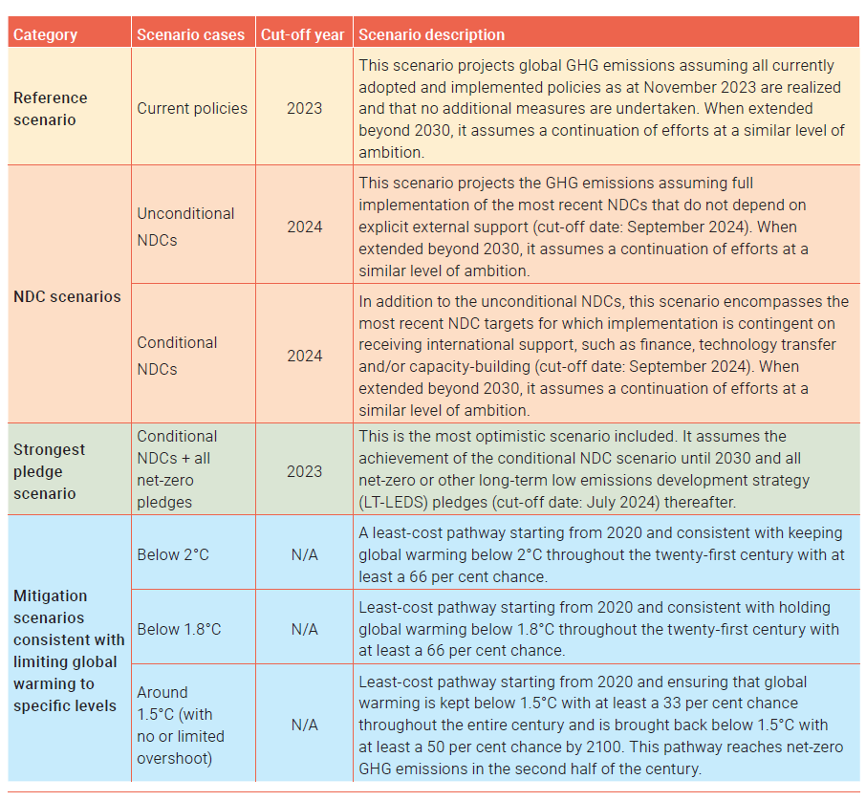

4.2.1 Current policies scenarios
- Minor updates based on available studies (PBL, Climate Action Tracker, ENGAGE/ELEVATE modelling consortium, JRC and IEA).

4.2.2 Updated NDC and Current pledges scenarios
- Updates based on available studies. Model teams for new NDCs: PBL, Climate Action Tracker, possible WRI (Climate Watch: for NDC scenario), and JRC and University of Melbourne.
- Explain methodology for new NDC submissions.
[BOX 4.1: Other greenhouse gas projections under current policies and NDCs – methane and LULUCF.
State of play of methane emissions reduction policies and pledges and LULUCF policies and pledges. This box will provide an estimate of reductions in methane/LULUCF emissions between 2020 and 2030, 2035 and 2050 for a set of policy/NDC cases.
For LULUCF, it will also cover implications for global benchmarks of aligning climate scenarios to national GHG inventories – related to the BTR issues and LULUCF: highlight insights of most recent literature, state of play of LULUCF emissions are heading under current policies and pledges, possible also updating our harmonization of LULUCF estimates in the emissions gap
Depending on the material – this can become two boxes or a subsection in section 4.2.2
END BOX 4.1]

4.2.3 Scenarios keeping warming below specified temperature limits
- The following scenario categories will be covered:
  - 1.5°C pathways, starting from 2020, as counterfactual visual reference point
  - 1.8°C
  - 2.0°C
  - New pathways (name TBD), starting deepest possible reductions from 2025.
This category can be either be based on most recent scenario updates (but not yet confirmed that they will be available) or alternatively constructive informed by current emissions and emission reduction rates consistent with the most ambitious pathways in the IPCC database.

Table 4.2 [INDICATIVE TABLE – TO BE UPDATED] Global total GHG emissions in 2030, 2035 and 2050 and global warming characteristics of different scenarios consistent with limiting global warming to specific temperature limits
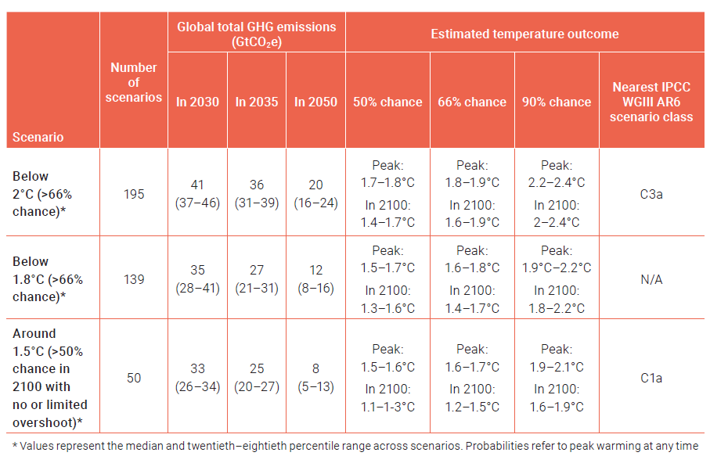

4.3 The emissions gaps in 2030, 2035 and 2050

4.3.1 The 2030 and 2035 emissions gaps
- INCLUDE OVERVIEW GAP TABLE
[BOX 4.2: Technical box on progress in climate policy
[DRAFT TEXT: DO NOT USE OR COPY]
Progress has indeed been made since Paris, as we see in the greenhouse gas (GHG) emissions projections of the various scenarios of the UNEP Emissions Reports since 2015 (Figure 4.1). Progress since the Paris Agreement is particularly notable in current policy scenarios. Globally, at the time of Paris, GHG emissions under current policies were projected to rise to 64 GtCO₂e by 2030, about a quarter above 2015 levels. Now, however, global GHG emissions are expected to reach 57 GtCO₂e, representing a reduction of 7 GtCO₂e and bringing them close to 2015 levels.
This decline is driven by (i) strengthened climate policies, which have led to declining emissions in industrialized countries over the past two decades and a leveling off of emissions growth in China; (ii) the rapid expansion of solar and wind energy, the fastest-growing energy sources globally; and (iii) macroeconomic developments, including lower economic growth projections.
NDC reduction targets have been strengthened over the years, particularly before and after the Glasgow International Climate Conference (2021). Global emissions projections for both NDC scenarios show similar reductions to those in current policy scenarios, with projections even falling below 2015 levels.
Projections for unconditional NDCs have decreased by 5 GtCO₂e, while those for conditional NDCs have dropped by 6 GtCO₂e. As a result, the current implementation gap for 2030 stands at 2 GtCO₂e for unconditional NDCs and 5 GtCO₂e for conditional NDCs—an improvement compared to 2015, when the gaps were 5 GtCO₂e and 7 GtCO₂e, respectively.
Despite this progress, the emissions gap remains substantial. The two-degree emissions gap has narrowed by 3 to 4 GtCO₂e since 2015. Additionally, our scientific understanding of the 1.5°C scenario has evolved over time.
[A SIMILAR DISCUSSION CAN BE ADDED ON PROGRESS IN TEMPERATURE PROJECTIONS]
Figure 4.1 Greenhouse gas emission projections from scenarios of the UNEP Emissions Gap report 2015, 2020 and 2024. Projections for the 2020 and 2024 reports have been corrected for method updates since the UNEP Emissions Gap report 2022 (see Table 4.2).
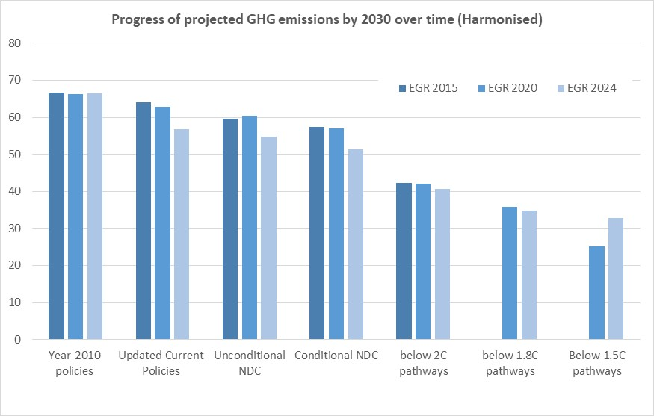
END BOX 4.2]

Figure 4.2 GHG emissions under different scenarios and the emissions gap in 2030 and 2035
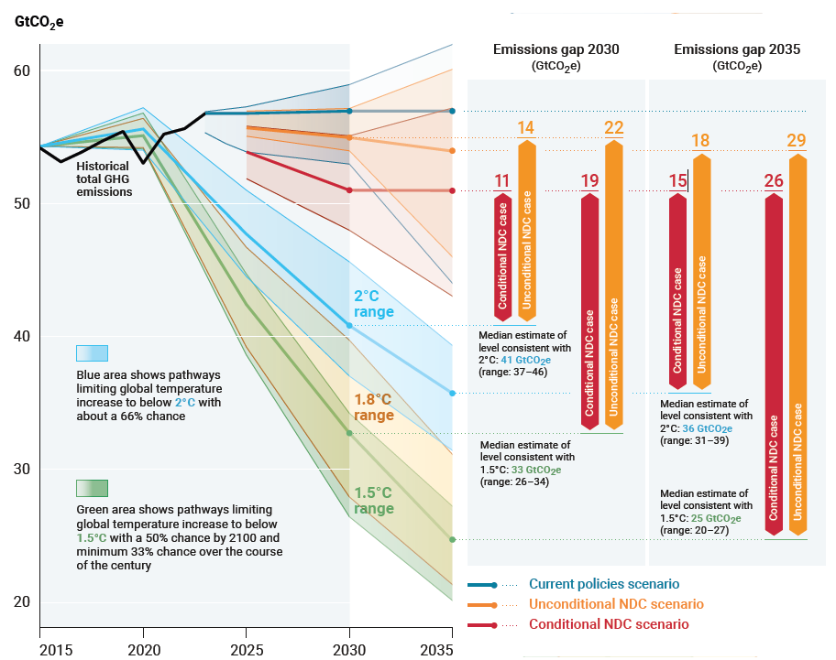

4.3.2 The 2050 emissions gaps
Table 4.3 [INDICATIVE TABLE – TO BE UPDATED] Global total GHG emissions in 2030, 2035 and 2050 and estimation of associated emissions gaps under different scenarios
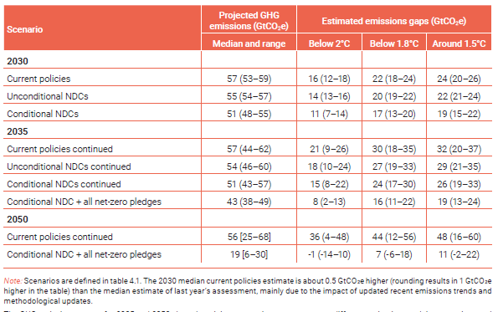

4.3.3 Gaps for other greenhouse gas emissions
There’s an ambition to estimate a methane and LULUCF emissions gap. Estimates from Box 4.2 would be compared to the assumptions in the temperature-aligned scenarios.

4.4 Temperature and other implications of the emissions gap
4.4.1 Negative emissions implications of delayed action and the emissions gaps
Net-negative emissions required under the most ambitious scenario to return warming to 1.5°C
[New visual showing negative emissions implications]

4.4.2 Implications of the methane and LULUCF gaps
Implications in terms of:
- Global warming
- Air quality

4.4.3 Temperature implications of various scenarios
Heads up: almost irrespective of the NDC updates, it is expected that the temperature projections of all scenario cases will be higher than last year’s for different reasons. Besides providing the temperature projections, this section will clarify the reasons behind these differences.
[BOX 4.3 – Earth system feedbacks and overshoot
- Impacts of Earth system feedbacks on magnitude and extent of overshoot
- Impact of overshoot on amplifying Earth system feedbacks
END BOX 4.3]
Scenarios for which temperature implications will be assessed (highlighting difference in uncertainty due to scenario assumptions and due to climate response)
- Extension of Current Policy until 2030
- Extension of NDCs in 2030 in absence of LTS thereafter
- Scenarios with NDCs and LTS with assessment of their credibility of delivery.
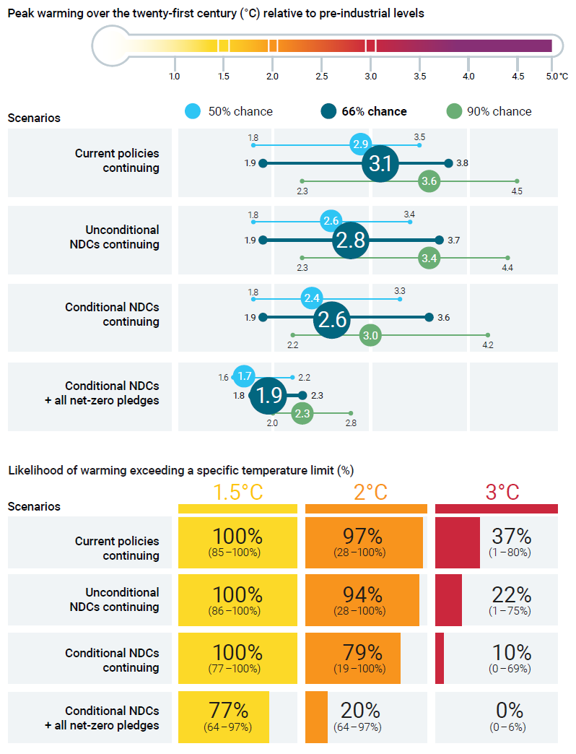

Chapter 4 latest reference updates
den Elzen, M. G., Dafnomilis, I., Nascimento, L., Beusen, A., Forsell, N., Gubbels, J., ... & Kuramochi, T. (2025). Uncertainties around net‐zero climate targets have major impact on greenhouse gas emissions projections. Annals of the New York Academy of Science, Volume 1544, Issue 1, February 2025, Pages 209-222, https://doi.org/10.1111/nyas.15285
Keramidas, K., Fosse, F., Aycart Lazo, F.J., Dowling, P., Garaffa, R., Ordonez, J., Petrovic, S., Russ, P., Schade, B., Schmitz, A., Soria Ramirez, A., van Der Vorst, C. and Weitzel, M., Global Energy and Climate Outlook 2024, European Commission: Joint Research Centre, Publications Office of the European Union, Luxembourg, 2025, https://data.europa.eu/doi/10.2760/9028706 , JRC139986.
Nascimento, L., Scheewel, J-L, Kuramochi, T., Dafnomilis, I., Hooijschuur, E., den Elzen, M., Forsell, N., Gutiérrez, Z.A., Missirliu, A., Woollands, S., Zhang, N., Wong, J., Hagemann, M., Salsabila, N. P., Fekete, H., de Vivero, G., Pelekh, N., Godinho, C., de Villafranca Casas, M. J., Bos, A., Gusti, M. “Progress of major emitters towards climate targets: 2024 Update.” NewClimate Institute, Cologne, Germany, https://newclimate.org/resources/publications/progress-of-major-emitters-towards-climate-targets-2024-update

